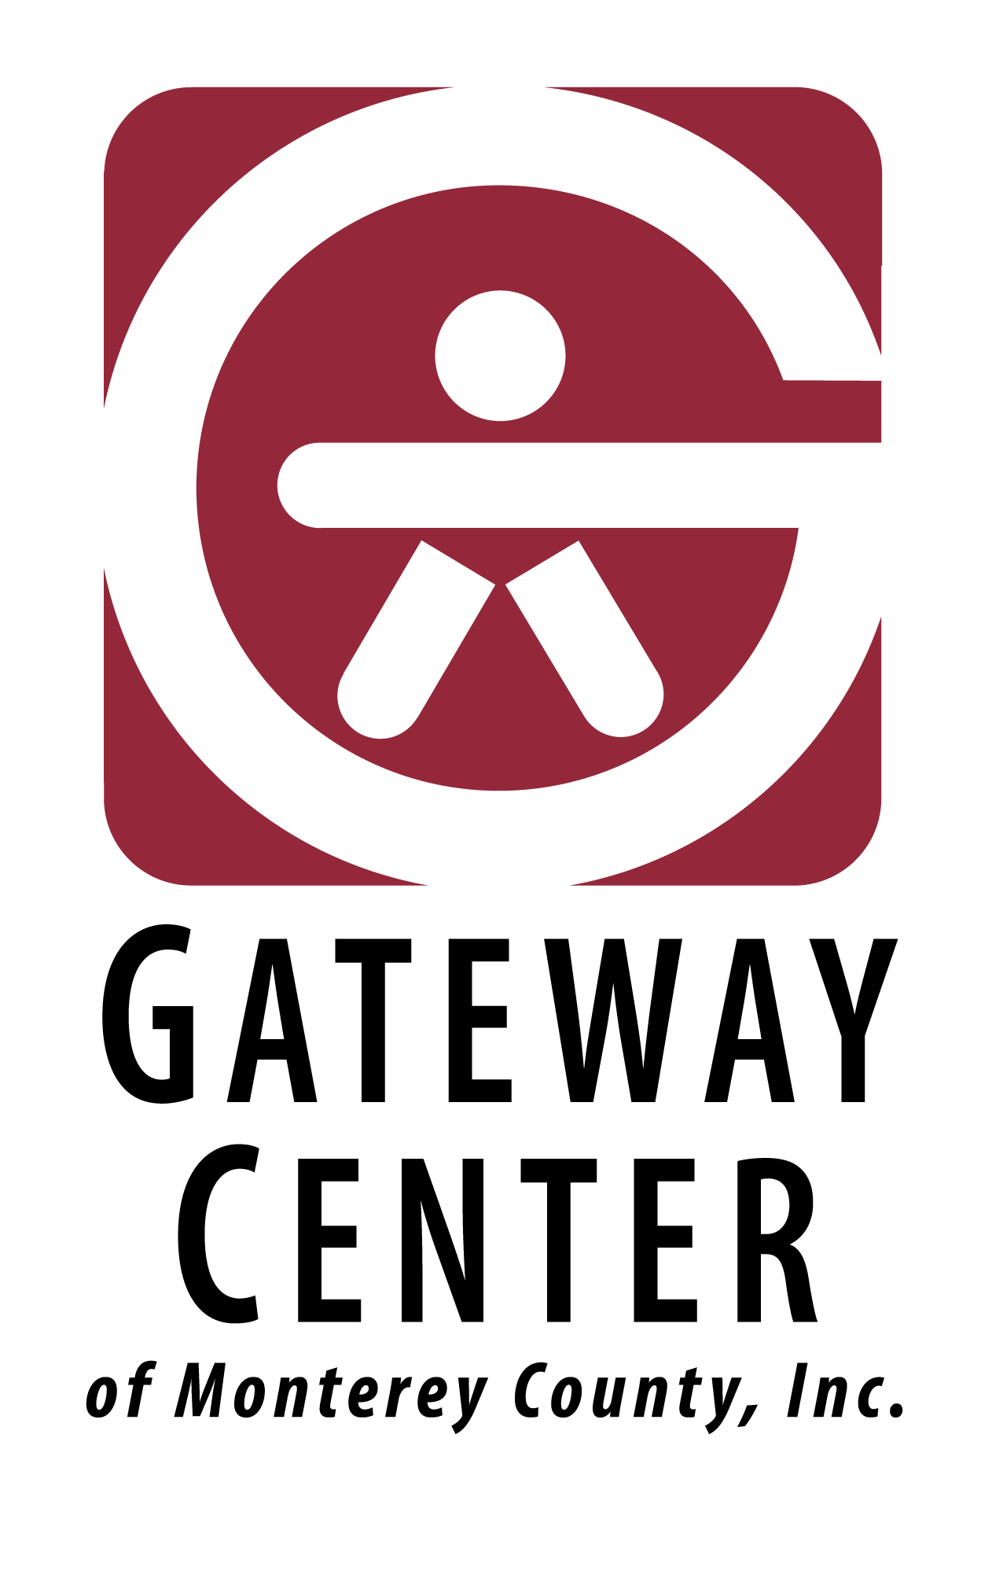

Stock Donation Form

Thank you for your generous gift to Gateway Center of Monterey County, helping to ensure that every person served by our organization is able to achieve meaningful, joyful and productive lives. You can make your gift of securities in two easy steps:

- Initiate the transfer Electronic delivery of stock shares is the most secure and expedient delivery process available.
Please provide the following instructions to your broker:
Deliver to:
Merrill Lynch
DTC Clearning8862
FBO: Gateway Center of Monterey County Inc
Destination Account: 782-XXXXX
Tax ID Number: 94-2660677

Wire:
Destination Bank: Bank of America
ABA: 026009593
Swift: BOFAUS3N
Account Name: Merrill Lynch
Account Number: 65501135516
Bank Address: 100 West 33rd Street
New York, NY 1001
For Further Credit: Gateway Center of Monterey County Inc 782-XXXXX

- Notify Gateway
Please fill out the form below, so that we can acknowledge your gift and provide you with a tax receipt.
Donor Information
____________________________________________________
Name

Address
_____________________ ___________ __________
City State Zip Code __________________________________ ______________
Email Address Phone

Donation Information
_____________ _____________________________________
Today’s Date Date of Transfer
_______________ _____________________________________
Number of Shares Name of Security & Ticker Symbol ____________________________________________________
Transferring Broker

Please return your completed form by mail, fax, or email to:
Robert Freiri, Executive Director rfreiri@gatewaycenter.org (831) 372-8002
Gateway Center of Monterey 850 Congress Avenue Pacific Grove, CA 93950

Officers and
Board of Directors

Jim Landman
Chair

Jeannette Fassler-Walker
Vice Chair

Rachelle Hill
Secretary

Leon Heller
Treasurer

Kristina Olfson
Terry Wecker
Brad Barbeau
Dave Tanis
Helene Lubben

Emeritus
Chris Panetta
Bruna Odello
Mezola Benton
William Parham
Mary Lou Cortright

Robert Freiri
Executive Director

Gateway Center of
Monterey County, Inc.
850 Congress Avenue
Pacific Grove, CA 93950
831-372-8002
Fax 831-372-2411
info@gatewaycenter.org
www.gatewaycenter.org

State of California
Department of Social
Services Facility Numbers:
270707828
270702591
275201316
275202604

